3. Methodology
The proposed system is a hybrid model in fusion of Autoencoder (AE) and Vision Transformer (ViT) with Explainable AI (XAI) to predict the type of brain tumor and the region of the presence of a brain tumor. This section elaborates on the methods used to train the proposed Deep Learning (DL) model [23].
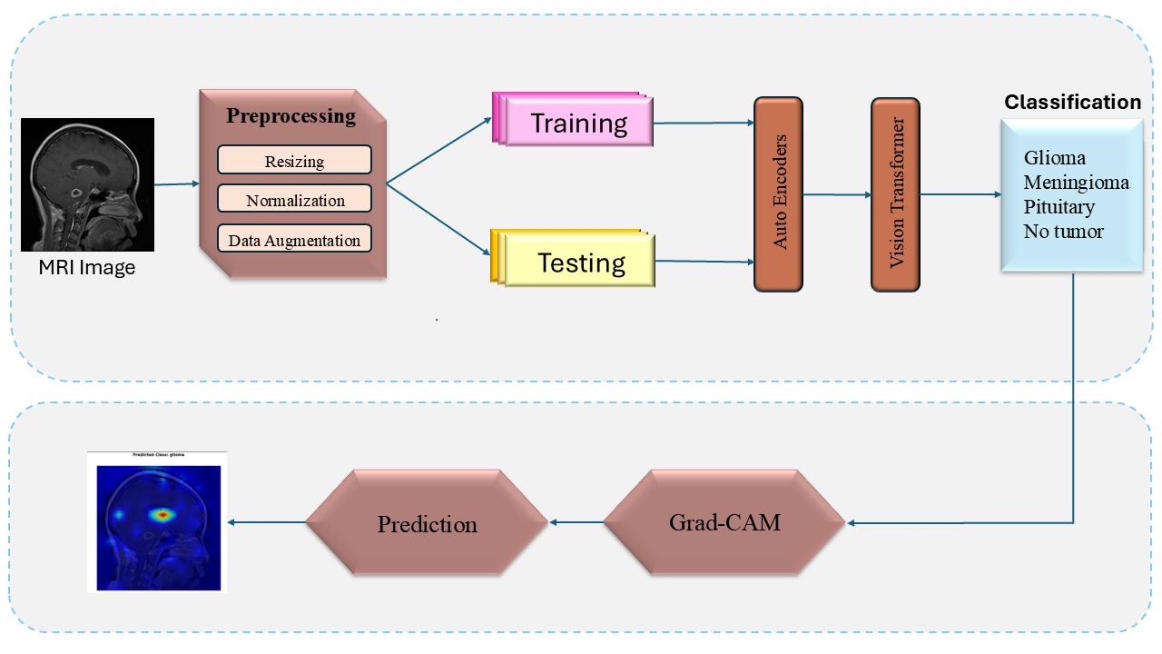
Figure 1 AE+ViT: An Explainable Framework for MRI-based Brain Tumor Classification
3.1 Dataset Collection
The data of this research were utilized from the publicly available brain tumor MRI Dataset on Kaggle. It is based on 10,288 magnetic resonance imaging (MRI) scans of brain tumors whose classification includes four groups: Glioma, Meningioma, Pituitary tumor, and No tumor. The images are grouped by tumor type and anatomical orientation, and are annotated by experts in order to be corrected. This heterogeneous and equalized data is a good basis to train and assess deep learning models [21]. The data was separated into two subsets as training and testing with an 80:20 ratio in a disproportional class distribution.
3.2 Data Preprocessing
The Data preprocessing stage involves resizing of all MRI brain input images to a uniform size, which is compatible with the Vision Transformer (ViT) input. The pixel intensity values are then normalized to normalize the input distribution. To make the model more universal, it is possible to use augmentation techniques like rotation, flipping [21].
3.3 Autoencoder
The autoencoder component of the proposed architecture contains an unsupervised feature extractor, which converts every pre-processed MRI image into a small latent code [23]. The architecture will include an encoder, which employs a sequence of convolutional and pooling layers to extract image features of a higher level and reduce the dimensionality. Afterward, a bottleneck layer is used, where the most significant information is captured to be used in downstream tasks. The decoder is the reflection of the encoder, based on upsampling and transposed convolutional layers to rebuild the original picture in its presented compressed version. Let E_{φ} refer to the encoder parameterized by φ and D_{θ} refer to the decoder parameterized by θ . The output is referred to as the reconstructed input $\hat{x_{i}}$ is obtained from $x_{i}$ as shown in equation (1).
$\hat{x_{i}}=D_{θ}\left(E_{}\left(x_{i}\right)\right)$ (1)
Where $x_{i} ∈R^{H X WX C}$ is the input MRI image samples with H, W and C as height, width and channel, respectively. Minimizing the reconstruction loss, referred to as Mean Squared Error (MSE) between the output and input images as shown in equation (2), is the basis for training the autoencoder.
$£\left(,θ\right)= \frac{1}{N}\sum_{i=1}^{N}{{\left\|x_{i}- \hat{x_{i}}\right\|}^{2}}$ (2)
By encouraging accurate reconstruction, the autoencoder learns to retain key structural and pathological details relevant to brain tumor detection [21]. The resulting encoder latent codes are then used as input features to the Vision Transformer (ViT) to maintain the most informative elements of every MRI scan and utilize it to classify that element. To match the ViT patches, the output $z=E_{}\left(x_{i}\right)$ of the encoder is embedded as patch-wise as given in equation (3).
$z∈R^{p X d}$ (3)
Where p is the patch size and d is the dimensionality latent space. This method increases the robustness, reduces the dimensions, and assists the overall pipeline to concentrate on medically significant visual patterns against the complicated MRI data. The Adam optimizer is used to perform training, and the early stopping criteria help to avoid overfitting of the model and provide stable convergence.
3.4 Vision Transformer
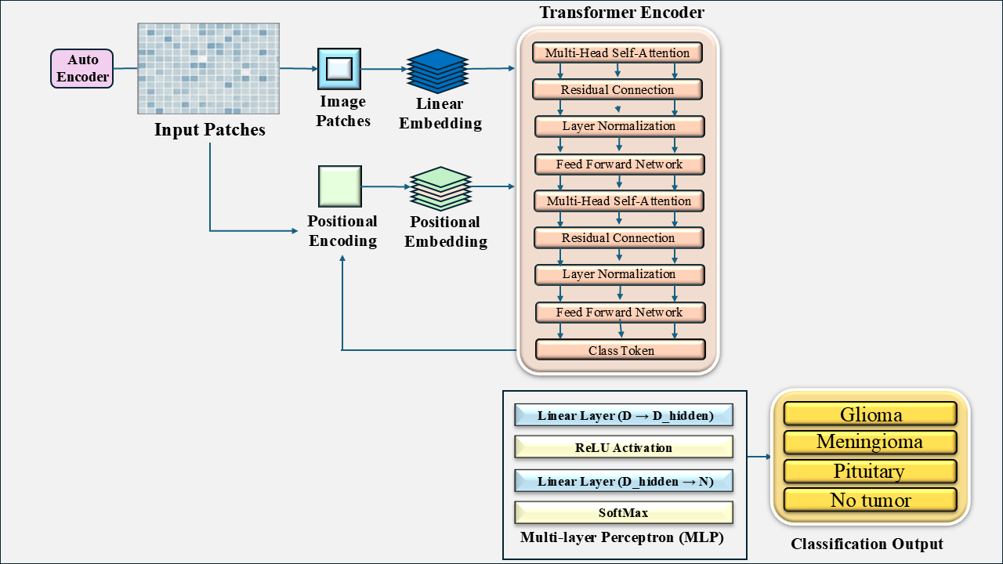
Figure 2 Architectural Pipeline of the Vision Transformer (ViT) for Brain Tumor Classification.
The pre-processed images are divided into constant-sized(p) patches. The patches are flattened to produce patch embeddings, which are projected into an embedding (feature) space [22]. Positional encodings are also included with the patch embeddings to maintain the spatial information as shown in equation (4).
$z_{0}^{i} = {\hat{x}}_{p}^{i}W_{e}+ E_{pos}^{i}$ (4)
Where $\hat{x_{p}}$ is the i^{th} patch of the input for the transformer, $W_{e}$ is the Patch embedding projection matrix, $E_{pos}^{i}$ is the positional encoding for i^{th} patch. The proposed model consists of two transformer encoder blocks, each possesses three sub-layers, namely Multi-Head Self-Attention (MHSA), residual connections with layer normalization, and Feed Forward Network (MLP). The attention model computes the attention signal for layer $‘l’$ from the previous layer $Z_{l-1}$ and learned projection weight matrices $W_{Q},W_{k}{,W}_{V}$ for the $'d'$dimension of attention head ss given in equation(5 to 8). The dimension of $Z_{l}$ is as same as $Z_{l-1}$.
$MHSA\left(Q_{l},K_{l}, V_{l} \right)=softmax\left(\frac{{Q_{l}K_{l}}^{T}}{\sqrt{d}}\right)V$ (5)
Where $Q_{l}= Z_{l-1}W_{Q}$ (6)
$K_{l}=Z_{l-1}W_{k}$ (7)
$V=Z_{l-1}W_{V}$ (8)
To ensure the stability and better gradient flow, the residual connection and layer normalization unit in the ViT model perform a computation as shown in equation (9). The normalized output is feed into a Multi-Layer Perceptron, a two-layer fully connected feed-forward network with a GELU activation to fetch the output $Z_{l}$ as shown equation(10).
$Z^{(l)}´$ = $Z^{(l-1)}+MHSA(Z^{l-1})$ (9)
$Z_{l}={MLP(Z}^{(l)}´)$ (10)
Layer-wise processing of the embedding patches is done by the multi-head self-attention mechanisms and feed-forward neural networks in the transformer encoder [26]. The termination of both layers of multi-head self-attention mechanisms and feed-forward neural networks is done by layer normalization and residual connections to every process. A [cls] token, learnable token generated at input to denotes the global representation after 2 transformer layers as given in equation (11).
$T=W_{cls}Z_{cls}^{(2)}+ b_{cls}$ (11)

Where $Z_{cls}^{(2)}$ is the final hidden state of [cls] token after the last(transformer 2) layer, $W_{cls}$ is the classification weight matrix and $b_{cls}$ is the classification bias matrix. The order of the embedded patches is to first feed a special classification token (CLS) into the multi-layer perceptron (MLP) class classification head to generate the probability of the tumor type, as shown in equation (12).
$\hat{Y}=softmax\left(T\right)$ (12)

3.5 Loss Computation
.Initially, the autoencoder is pretrained on all MRI images, consisting of labelled and unlabelled, to minimize the reconstruction loss $£\left(,θ\right)$ as shown in equation (2). Then autoencoder with ViT is trained to minimize the combined loss $£_{c}$ as given in equation (13) [23].
$£_{c}= λ_{cls}£_{cls}\left(Y,\hat{Y} \right)+λ_{ae}£_{ae}\left(x, \hat{x}\right)$ (13)
Where $λ_{cls}$ and $λ_{ae}$ are hyperparameters of ViT and the autoencoder, respectively.$£_{cls}\left(Y,\hat{Y} \right)$ is the cross-entropy loss of the ViT and $£_{ae}\left(x, \hat{x}\right)$ is the reconstruction loss of the AE. The model is trained using the labelled MRI images and distinguishes among the four types of tumors in the brain, namely Glioma, Meningioma, Pituitary tumor, and No tumor. The goal of the training is to minimize the composite loss, which involves cross-entropy classification loss and reconstruction loss of AE with suitable weighting parameters. The joint loss is minimized by adopting the Adam optimizer. During the test stage, the trained model estimates the presence and the type of tumor in invisible MRI images using the representations of the Autoencoder and Vision transformer.

3.6 Explainability with Grad-CAM:
The Gradient-weighted Class Activation Mapping (Grad-CAM) technique is applied to interpret the decision-making process of the proposed hybrid model [25]. It creates a visual output to show the most affected region of the input MRI data that determines the classification results for different tumor types. The method generates a basic localization map of important regions by tracking target class gradients that move through the final convolutional or attention layer. The importance weight of the kth feature map for class c is shown in equation (14).
$α_{k}^{c}=\frac{1}{Z}\sum_{i}{\sum_{j}{\frac{{∂y}^{c}}{{∂A}_{ⅈj}^{k}}}}$ (14)
Where $A_{ij}^{k}$ is the activation at spatial location in feature map k, $y^{c}$ is the predicted output of class c, and Z is the normalization factor in the feature map (Z=H X W). $α_{k}^{c}$ refers to the average influence of the feature map on class c. The localization map for class c is determined as shown in equation (15).
$L_{GradCAM}^{c}= ReLU\left(\sum_{k}{∝_{k}^{c}A^{k}}\right)$ (15)
It is computed by the weighted sum of all feature maps as per the importance value. The features with a positive influence on the target class are retained using the ReLU function. The generated heatmap, on a specific region of tumor class, plays the greatest role in the interpretation of the model's prediction for that class [20,24]. The proposed pipeline of methodology offers a head start of sophisticated transformer-based modelling, preprocessing, and explainability to secure excellent brain tumour detection on the basis of MRI images.

